# **Embedded Systems Essentials with Arm: Get Practical with Hardware**

# Module 1

KV1: Serial Communication Overview

Serial communication differs from parallel communication. In parallel communication, all the bits in a digital word are transmitted at the same time. So, for a 32-bit word, you’d need 32 wires, which adds up to a lot of wires. Another way of transmitting a digital word is through what’s called serial communication, where you send one bit at a time and you need far fewer wires.

The technology used to transmit data in serial communication is a shift register. This works much like a row of people passing buckets to each other. If a bucket is full, that counts as a 1. If a bucket is empty that counts as a 0. They all pass the buckets at the same moment, and that moment is when a clock signal ticks as it goes from 0 to 1 or 1 to 0. The shift register then passes those bits down the line. At the end of the shift register, those bits could be transmitted to the outside world and/or they could be received by another shift register, where they are clocked in one by one and the receiving device reads them in parallel. The shift register acts as a receiver or a transmitter, and also as a serial-to-parallel converter or parallel-to-serial converter.

In this diagram, we can see the clock ticking away, with the data changing on every clock cycle as the bits are transmitted.

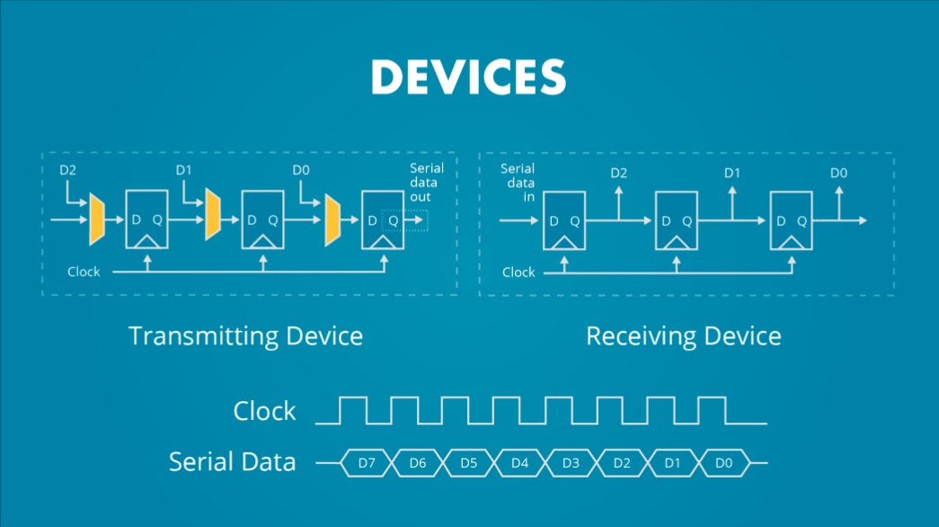

In order for the receiver to make sense of the incoming data, it has to know when a new transmission is starting, and when one bit ends and the next begins. For this reason, the clock should be active at the receiver as well as the transmitter. This gives rise to two types of serial communication: Synchronous and asynchronous.

With synchronous, you send the clock out from the transmitter to every node that’s receiving the data. In asynchronous communication the receiver has to make up its own clock. This is done by agreement between sender and receiver on the frequency of the clock. Framing bits indicate the beginning and end of a new data word.

**Visit arm.com for more information.**